PV*SOL 3D shading results

**Test Case 1**

In the first test case, a box was placed near a south facing module in Denver CO, with the following geometric parameters:

|  |  |  |
| --- | --- | --- |
|  |  |  |

This was represented in PV*SOL as:  
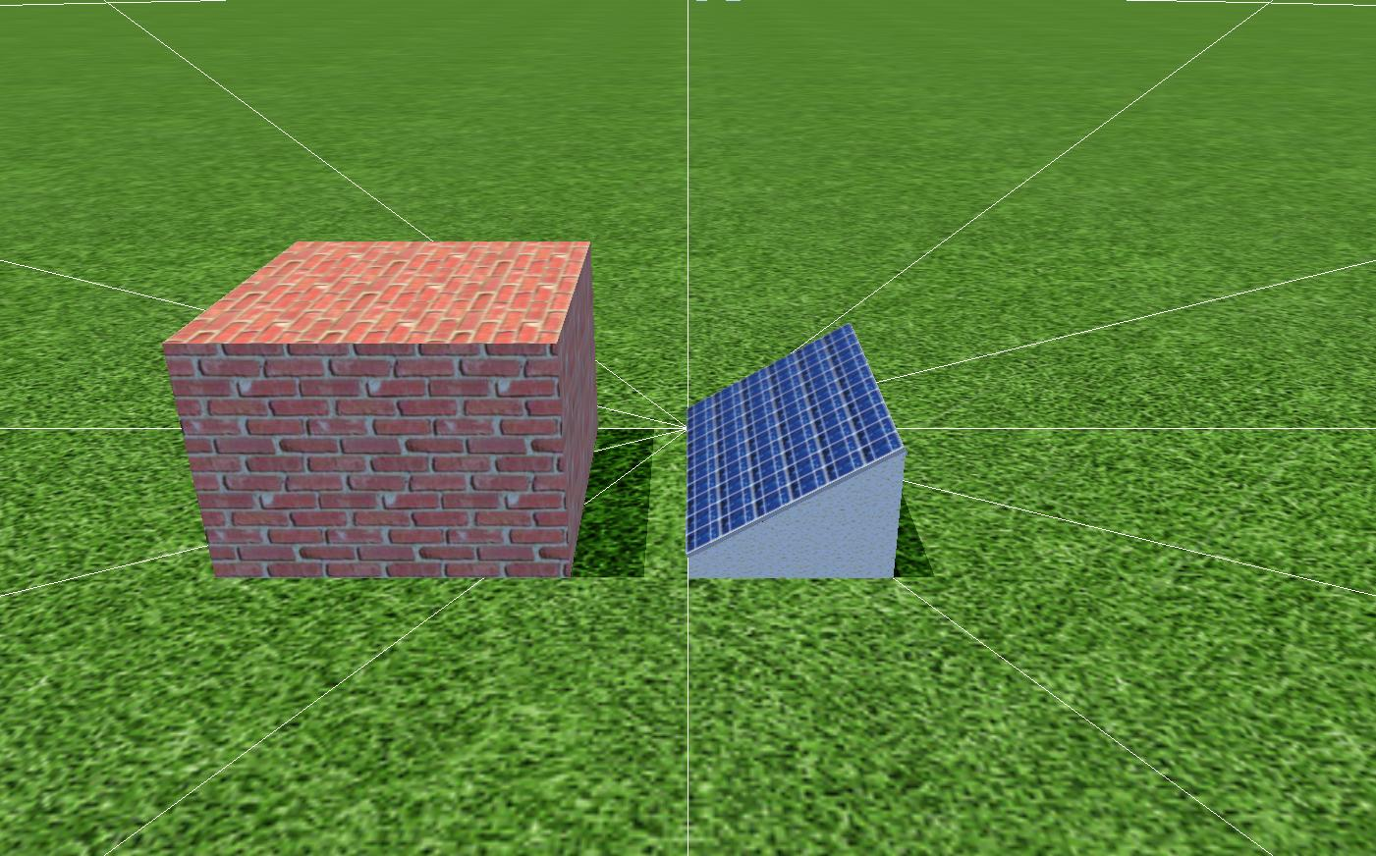

With the following specifications for the module and wall:

|  |  |  |
| --- | --- | --- |
|  | PV Module | Wall |
| X position [m] | 0.0 | 0 |
| Y position [m] | 0.0 | 2.0 |
| Z position [m] | 0.1 | 0 |
| Length [m] | 1.5 | 1.5 |
| Width [m] | 1 | 1.5 |
| Height [m] | NA | 1.1 |
| Tilt [degrees] | 30 | NA |
| Orientation [degrees] | 180 | NA |

Note, due to restrictions in PV*SOL, the module could not be mounted flush with the ground. To compensate for this, the height of the wall was increased by 0.1 m, which is the minimum height above the ground allowed in PV*SOL.

The output results from PV*SOL are difficult to compare directly to SAM results due to differences in methodology between the two models. In PV*SOL, horizon shading effects reduce the diffuse component of the radiation seen by the module. Once the radiation is converted into rated PV energy, the PV energy is then reduced by the module-specific partial shading. In SAM, shading losses are applied by reducing the plane-of-array beam solar irradiance and a applying a single sky diffuse loss.

For the initial comparison, the shading loss percentage for PV*SOL was computed by first taking the horizon shading loss, converting to kWh, and then multiplying by the PV efficiency to convert to effective PV power lost:

$$L_{h}=L_{h, kWh/m2}Aη$$

Then:

$$\begin{matrix}if \left(L_{h}<0 or L_{m}<0\right) \\ then (L_{p}=100*abs(\frac{L_{m}+L_{h}}{P_{pv}+L_{h}}) \\ else (L_{p}=100)\end{matrix}$$

Where:

|  |  |
| --- | --- |
| $$L_{h}$$ | Effective horizon shading loss (kWh) |
| $$L_{h, kWh/m2}$$ | Horizon shading loss (kWh/m2) |
| $$L_{m}$$ | Module shading loss (kWh) |
| $$L_{p}$$ | Loss percent (%) |
| $$P_{pv}$$ | Rated PV energy (kWh) |
| $$A$$ | Module area (m2) |
| $$η$$ | Panel efficiency (%) |

For the first day of the year, SAM and PV*SOL losses look like:

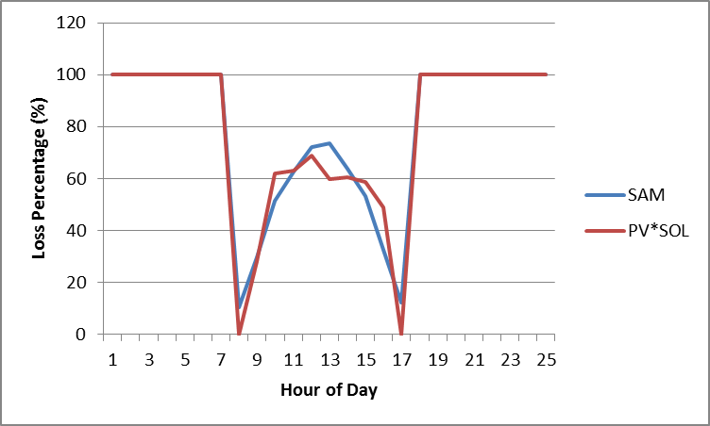

Clearly some differences exist in the general shape of the curve; however, on an annual basis the loss percentages vary by only 7.47%.

**Test Case 2**

In the second test case a south facing PV module was placed between two boxes in Quito, Ecuador.

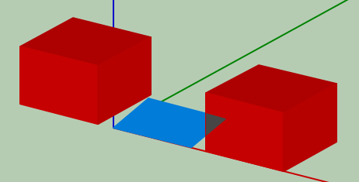

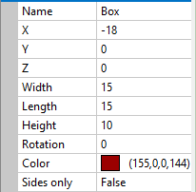 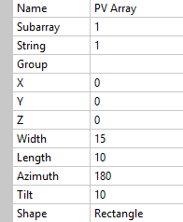 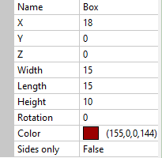

This was represented in PV*SOL as:

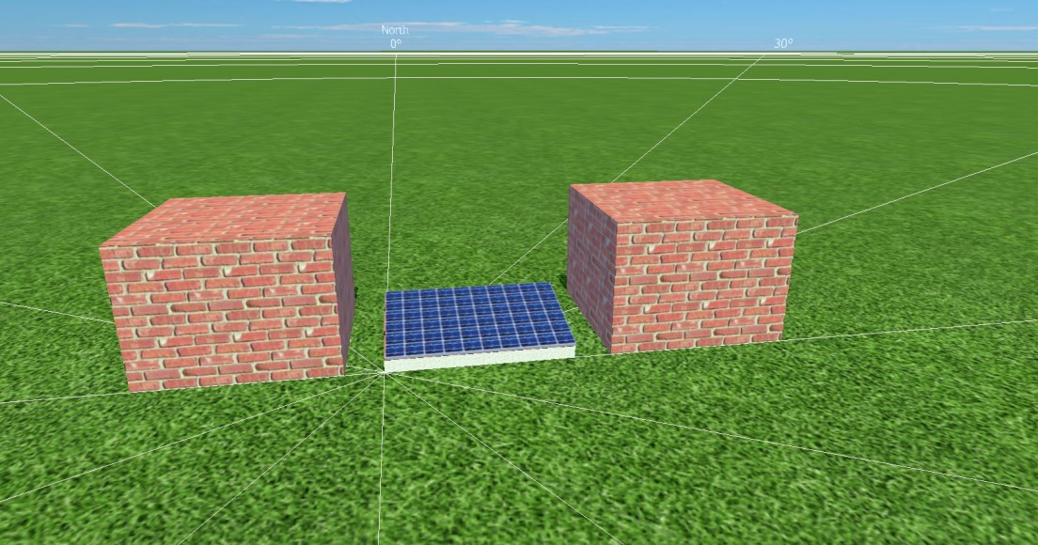

With the following specifications for the module and walls:

|  |  |  |  |
| --- | --- | --- | --- |
|  | PV Module | Right Wall | Left Wall |
| X position [m] | 0.0 | -1.8 | 1.8 |
| Y position [m] | 0.0 | 0 | 0 |
| Z position [m] | 0.1 | 0 | 0 |
| Length [m] | 1.5 | 1.5 | 1.5 |
| Width [m] | 1 | 1.5 | 1.5 |
| Height [m] | NA | 1.1 | 1.1 |
| Tilt [degrees] | 10 | NA | NA |
| Orientation [degrees] | 180 | NA | NA |

The first day of the year shading compared to SAM:  
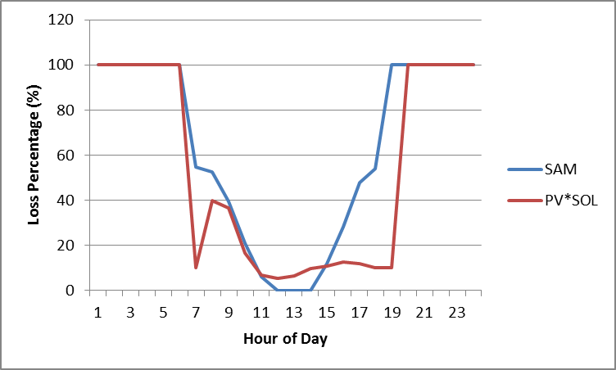

With a total annual difference of 13.3%.

**Test Case 3**

In the third test, a northeast facing PV panel is shaded by a box in Perth Australia.

|  |  |  |
| --- | --- | --- |
|  |  |  |

This is represented in PV*SOL as:  
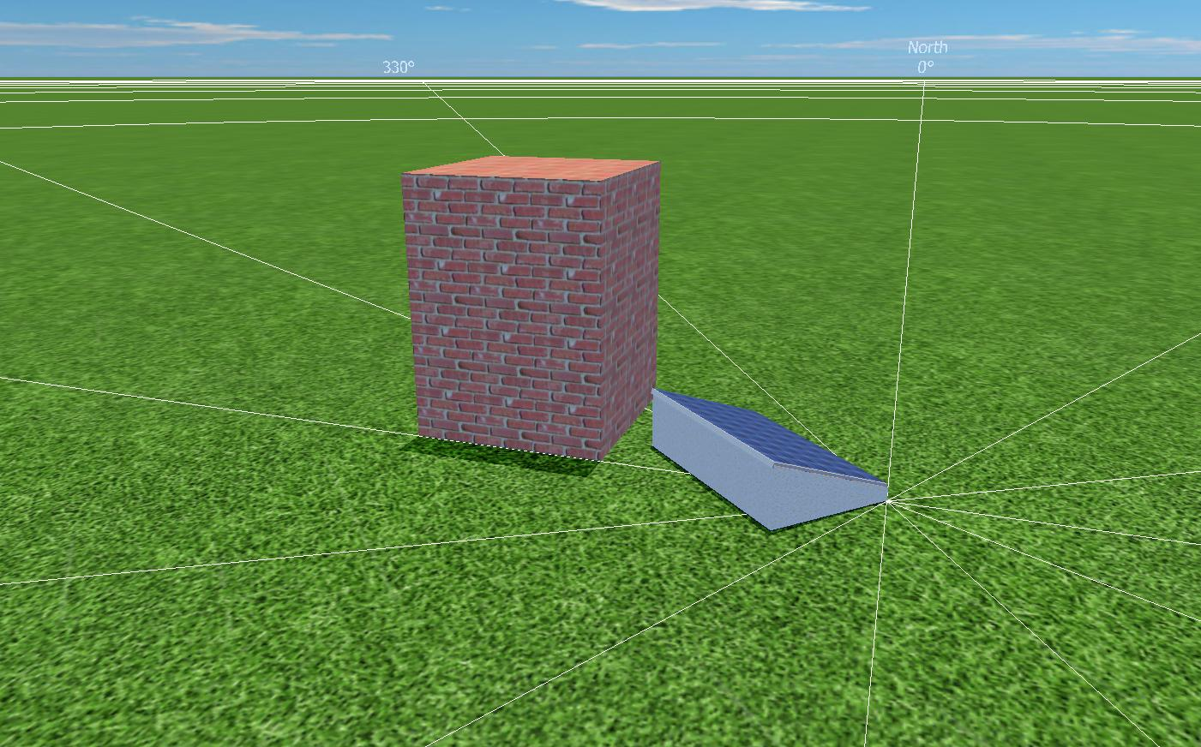

With the following specifications:

|  |  |  |
| --- | --- | --- |
|  | PV Module | Wall |
| X position [m] | 0.0 | 3.5 |
| Y position [m] | 0.0 | 0.0 |
| Z position [m] | 0.1 | 0.0 |
| Length [m] | 1.5 | 1.5 |
| Width [m] | 1 | 1.5 |
| Height [m] | NA | 2.1 |
| Tilt [degrees] | 20 | 0 |
| Azimuth [degrees] | 45 | 180 |

The first day of the year shading compared to SAM:

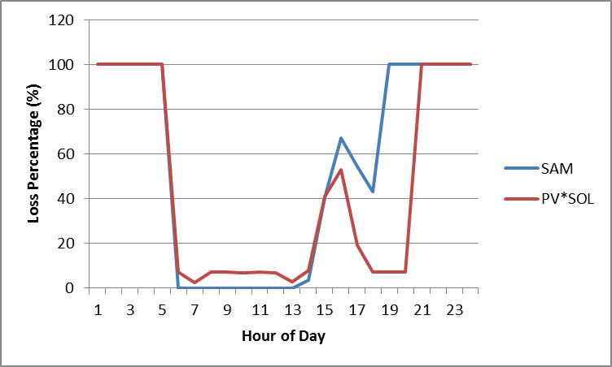

With a total annual difference of 12.1%